**Power BI Inflation Analysis: Journeying Through Global Economic Terrain**

**Introduction :**

Inflation, a critical economic indicator, profoundly impacts businesses, consumers, and policymakers worldwide. In this scenario, a multinational corporation operating in diverse markets seeks to optimize pricing strategies, mitigate risks, and make informed investment decisions. Leveraging Power BI's analytical prowess, we delve into inflation data to offer tailored recommendations aligned with each market's unique economic conditions.  
  
Our approach involves data collection, preparation, and modeling to build a robust analysis framework. Through insightful visualizations and strategic recommendations, we aim to equip stakeholders with actionable insights for informed decision-making. Our deliverables include an interactive Power BI dashboard showcasing inflation trends and a comprehensive report summarizing analysis findings and recommendations.  
  
**Scenario 1:** Lack of Data Integration and Standardization  
In the context of "Power BI Inflation Analysis: Journeying Through Global Economic Terrain," a key problem might be the lack of standardized data sources and integration methods. Different regions and organizations may report inflation data differently, leading to inconsistencies and challenges in aggregating and analyzing global inflation trends effectively within Power BI. This lack of standardization hampers the ability to provide accurate and comprehensive insights into inflation dynamics worldwide.  
  
**Scenario 2:** Limited Historical Data Accessibility   
Another challenge could be the limited accessibility to historical inflation data across various countries and regions. This scarcity of historical data poses a significant obstacle in building robust predictive models within Power BI for forecasting inflation trends accurately. Without a comprehensive historical dataset, analysts may struggle to identify long-term patterns and correlations necessary for making informed decisions and projections.  
  
**Scenario 3:** Complex Economic Interdependencies   
The intricate interdependencies among global economies pose a complex challenge in "Power BI Inflation Analysis: Journeying Through Global Economic Terrain." Fluctuations in one country's inflation rate can have ripple effects across other regions, making it difficult to isolate and analyze the drivers of inflation within individual economies. Effectively capturing and analyzing these interdependencies within Power BI requires sophisticated modeling techniques and access to diverse datasets, which may not be readily available or easily integrated into the analysis platform.

**Technical Architecture:**

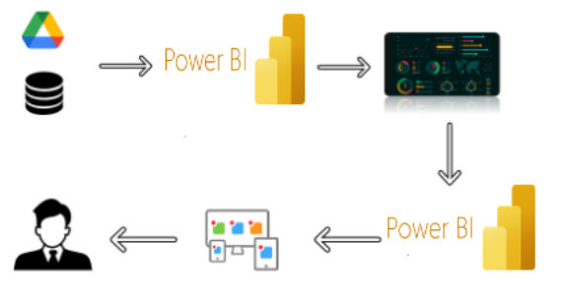

**Project Flow**

To accomplish this, we have to complete all the activities listed below,

* Data Collection & Extraction from Database
* Collect the dataset,
* Storing Data in DB
* Perform SQL Operations
* onnect DB with Power Bi
* Data Preparation
* Prepare the Data for Visualization
* Data Visualizations
* No of Unique Visualizations
* Dashboard
* Responsive and Design of Dashboard
* Report
* Responsive and Design of Dashboard
* Performance Testing
* No of Visualizations/ Graphs
* Project Demonstration & Documentation
* Record explanation Video for project end to end solution
* Project Documentation-Step by step project development procedure

**Milestone 1: Data Collection & Extraction from Database**

Data collection is the process of gathering and measuring information on variables of interest, in an established systematic fashion that enables one to answer stated research questions, test hypotheses, evaluate outcomes and generate insights from the data.

**Activity 1: Collect the dataset**

Please use the link to download:<https://www.kaggle.com/datasets/sazidthe1/global-inflation-data>**Activity 1.1: Understand the data**  
Data contains all the meta information regarding the columns described in the CSV files.  
Column Description of the Dataset:  
1) Country_name: Name of the Country.  
2) Inflation Rate: Inflation rate of each country.  
3) Region: Region of country which belongs  
4) Year:  represents the calendar year for which the corresponding inflation data is recorded.  
5) AdjustedInflationRate: The 'Adjusted Inflation Rate' column is derived by multiplying the inflation rate by 0.01  .  
6) InflationRateCategory:The 'Inflation Rate' column is categorized as           high, medium, or low based on predefined thresholds.

**Activity 2: Connect Data with Power BI**

With Power BI, users can seamlessly connect to a wide range of data sources, including databases, cloud services, spreadsheets, and streaming data. This capability allows organizations to consolidate disparate data sources into a single, unified platform, breaking down data silos and enabling holistic analysis.

**Milestone 2: Data Preparation**

Preparing the data for visualization involves cleaning the data to remove irrelevant or missing data, transforming the data into a format that can be easily visualized, exploring the data to identify patterns and trends, filtering the data to focus on specific subsets of data, preparing the data for visualization software, and ensuring the data is accurate and complete. This process helps to make the data easily understandable and ready for creating visualizations to gain insights into the performance and efficiency. Since the data is already cleaned, we can move to visualization.

**Activity 1: Prepare the Data for Visualization**

Preparing the data for visualization involves cleaning the data to remove irrelevant or missing data, transforming the data into a format that can be easily visualized, exploring the data to identify patterns and trends, filtering the data to focus on specific subsets of data, preparing the data for visualization software, and ensuring the data is accurate and complete. This process helps to make the data easily understandable and ready for creating visualizations to gain insights into the performance and efficiency.

**Milestone 4: Data Visualization**

Data visualization is the process of creating graphical representations of data to help people understand and explore the information. The goal of data visualization is to make complex data sets more accessible, intuitive, and easier to interpret. By using visual elements such as charts, graphs, and maps, data visualizations can help people quickly identify patterns, trends, and outliers in the data.

**Activity 1.1: Average Inflation Rate**

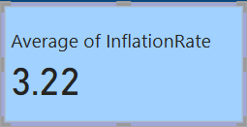

**Activity 1.2: Maximum Inflation Rate**

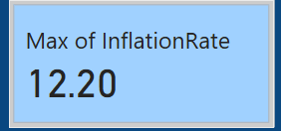

**Activity 1.3: Total Number of Regions**

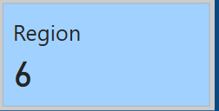

**Activity 1.4: InflationRate change over a year**

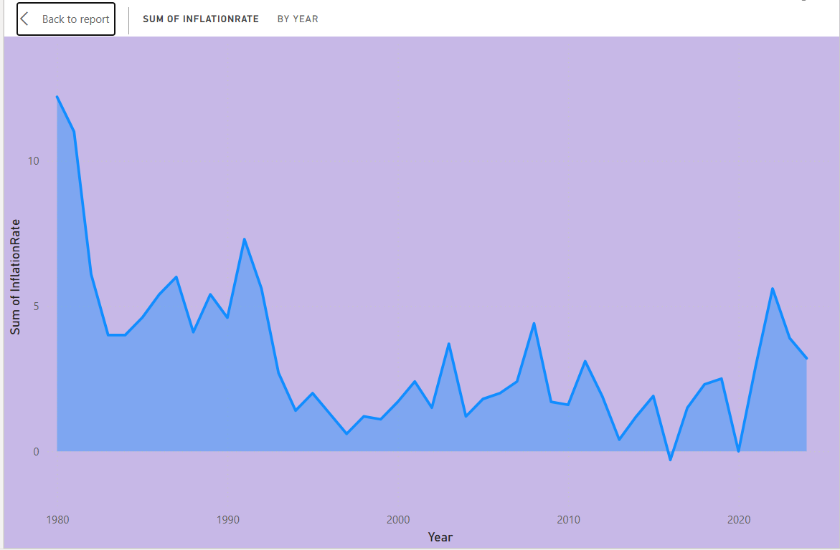

**Activity 1.5: Distribution Of Inflationrate Categories.**

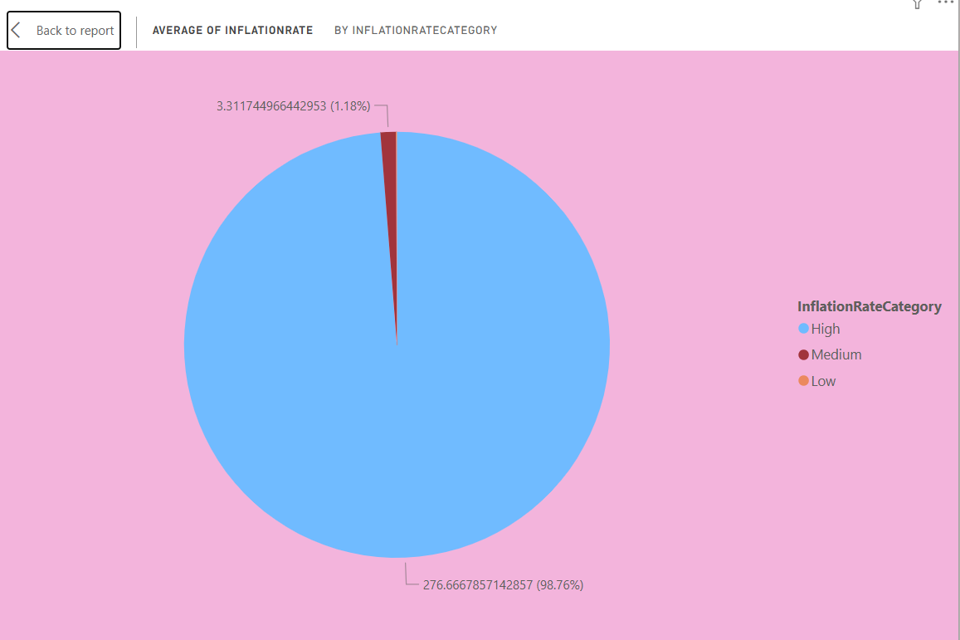

**Activity 1.6:  Filter applied On Country Column**

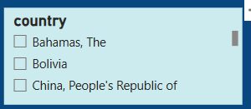

**Activity 1.7: Average Inflation Rate Change by Country**

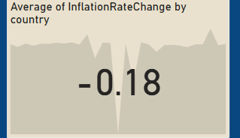

**Activity1.8:inflation rate and adjusted inflationrate change over years**

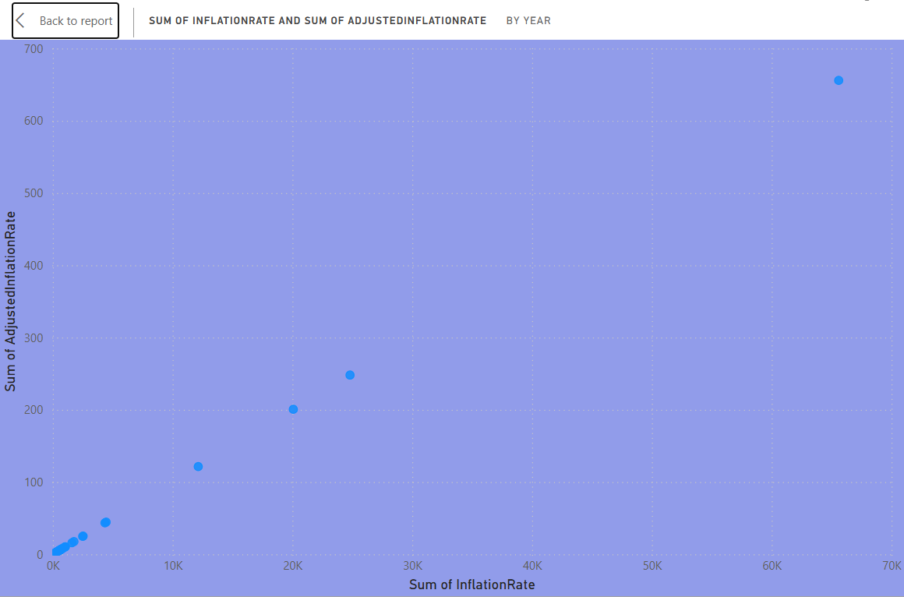

**Activity 1.9:Count of Region By country**

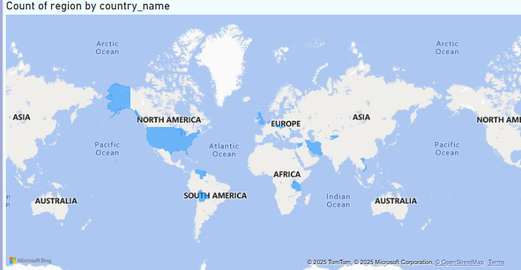

**Activity 1.10: inflation rate  Distribution**

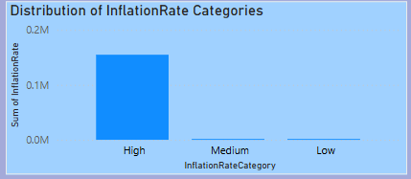

**Activity 1.11: Top 3 inflation rate Countries**

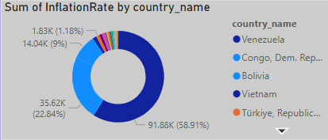

**Milestone 5: Dashboard**

A dashboard is a graphical user interface (GUI) that displays information and data in an organized, easy-to-read format. Dashboards are often used to provide real-time monitoring and analysis of data and are typically designed for a specific purpose or use case. Dashboards can be used in a variety of settings, such as business, finance, manufacturing, healthcare, and many other industries. They can be used to track key performance indicators (KPIs), monitor performance metrics, and display data in the form of charts, graphs, and tables.

**Activity :1- Responsive and Design of Dashboard**

Once you have created views on different sheets in Power Bi you can pull them into a dashboard.

**Explanation video link: <https://drive.google.com/file/d/1iKR8DZWm6CdAsyOT3Suy8H3uRjUGomsm/view?usp=sharing>**

**Dashboard**:

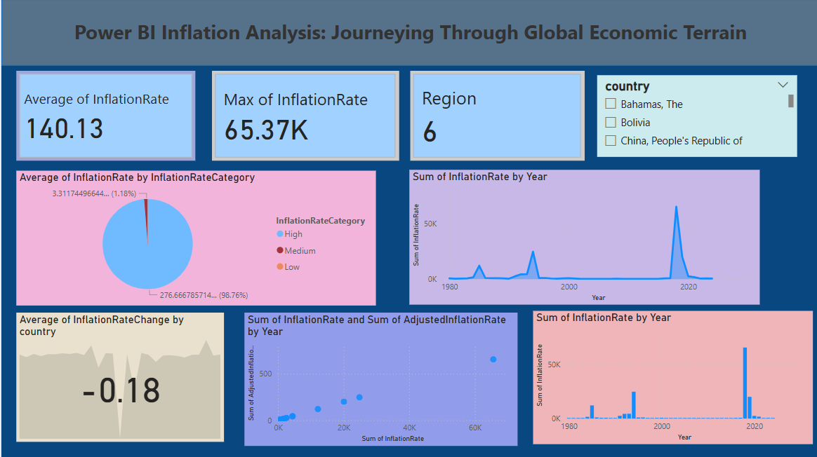

**Milestone 6: Report**

Designing a report in Power BI involves connecting to data sources, creating visualizations like charts and graphs, customizing their appearance and interactivity, organizing them logically on the canvas, formatting elements for consistency and clarity, and optionally creating dashboards for a summarized view. Throughout the process, it's essential to consider the audience's needs and ensure the report effectively communicates insights from the data. Finally, iterate based on feedback to continually improve the report's design and usefulness.

**Explanation video link:** <https://drive.google.com/file/d/1MPzrkfqfXFnCUjuGUXHGVQPpK2LCS8Sv/view?usp=sharing>

**A Design Of Report:**

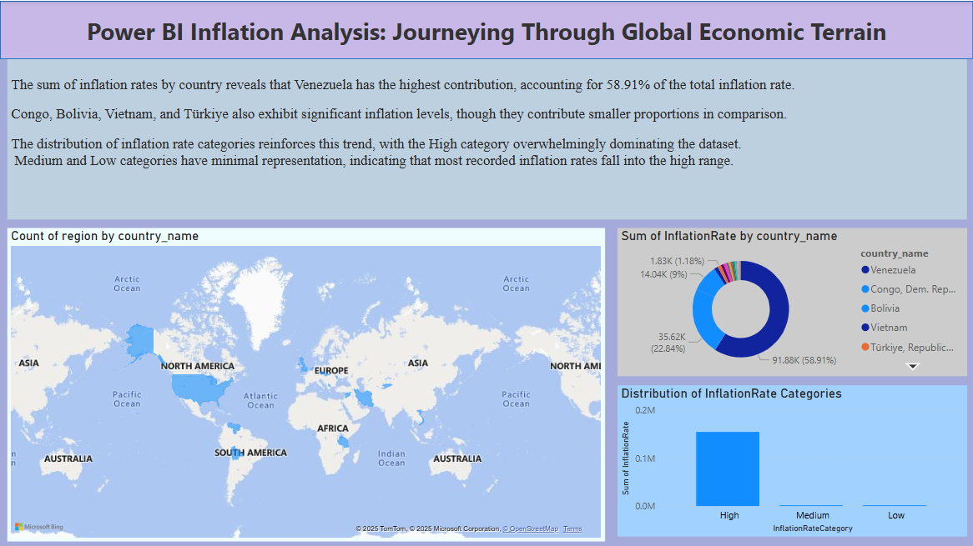

**Milestone 7: Performance Testing**

### **Activity:1- Amount of Data Loaded**

"Amount of Data Loaded" refers to the quantity or volume of data that has been imported, retrieved, or loaded into a system, software application, database, or any other data storage or processing environment. It's a measure of how much data has been successfully processed and made available for analysis, manipulation, or use within the system.

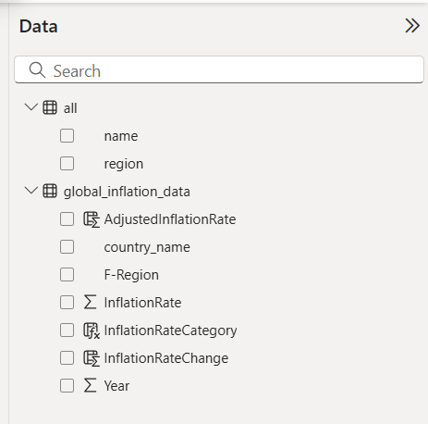

**Milestone 8: Project Demonstration & Documentation**

Below mentioned deliverables to be submitted along with other deliverables

**Activity 1:- Record explanation Video for project end to end solution**

Creating a record explanation video for a project's end-to-end solution is crucial for ensuring clarity and transparency in its implementation. This video serves as a comprehensive guide, detailing every aspect of the project from inception to completion.

**Activity 2:- Project Documentation-Step by step project development procedure**

Create document as per the template provided